Name: ______________________________ Date: ______________

Parallel Lines Activity

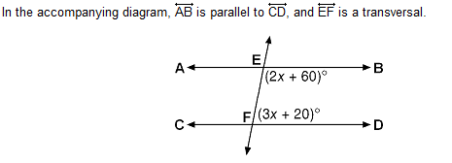
Find the measure of each angle in the diagram.

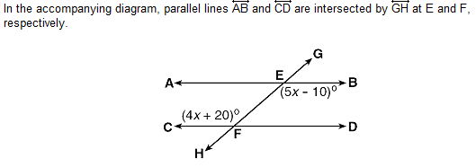
Find x and all of the missing angles in the diagram.

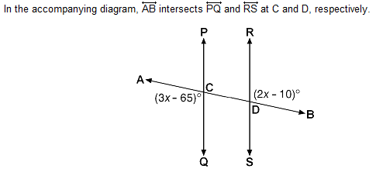
are parallel. Find x and all of the missing angles.

- The accompanying diagram shows two parallel lines cut by a transversal. Find all missing angles.
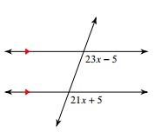

Parallel lines Task

Goal: Create a banner illustrating all of the angle pairs associated with parallel lines.

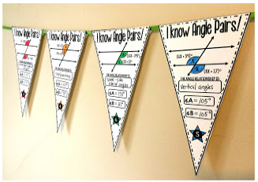

- Search on the internet for parallel lines cut by a transversal algebra questions (just like the ones we completed in class). You will need to find one question that deals with each of the following angle pairs: alternate interior angles, alternate exterior angles, corresponding angles, and same side interior angles. Print these questions out.

- Each banner flag should include a drawing of the two parallel lines cut by a transversal that you found and an algebraic solution (the work you did to find the answer). Be sure to include on the banner flag the name of the angle relationship that you are representing.

- Cut your flags out and use ribbon to create your banner. Your banner should be colorful, neat, and appealing. An extra banner flag is attached just in case you need it.

I KNOW ANGLE PAIRS!!

I KNOW ANGLE PAIRS!!

I KNOW ANGLE PAIRS!!

I KNOW ANGLE PAIRS!!

I KNOW ANGLE PAIRS!!

RUBRIC

 | 5 | 4 | 2
Participation | Student was actively engaged in the activity during the entire period. | Student was actively engaged in the activity for part of the period. | Student was not actively engaged in the activity during the period.
Accuracy | Banner included all angle relationships with no mathematical errors. | Banner included all angle relationships but included 1-2 errors. | Banner did not include all angle relationships.  OR  More than 2 errors were found.
Deadline | Student handed in project on time. | Student handed in project 1-2 days late. | Student handed in project 3-5 days late.  *Students who hand in a project more than 5 school days late will not receive any points for the category.

